# AI LAB ASSESSMENT

Aritro Pal

101803560

Q1.

import random import math

def get_cost(state):

dec = int(str(state), 2)

cost = (dec**3) - (60*(dec**2)) + (900*dec) + 100 return cost

def get_random_neighbour(state):

res = [int(x) for x in str(state)]

if(len(res)<5):

n = 5 - len(res) for i in range(n):

res.insert(0, 0)

i = random.choice(range(len(res))) if res[i] == 1:

res[i] = 0 else:

res[i] = 1

result = int("".join(str(i) for i in res)) return(result)

def simulated_annealing(init_state):

T = 500

delta_T = 0.9

n = 500

cur_state = init_state

print('Initial cost: ' + str(get_cost(cur_state))) for i in range(n):

neighbour = get_random_neighbour(cur_state)

cost_diff = get_cost(neighbour) - get_cost(cur_state) if cost_diff > 0:

cur_state = neighbour else:

if random.uniform(0,1) < math.exp(cost_diff/T): cur_state = neighbour

T = T - delta_T

print('Final cost: ' + str(get_cost(cur_state))) return cur_state

print(simulated_annealing(10011))

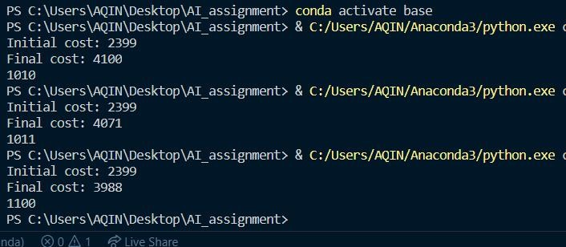

Q2.

|  |  |  |
| --- | --- | --- |
| from queue import Queue, PriorityQueue  def get_weight(from_node, to_node, weights=None):  return weights.get((from_node, to_node), 10e100) if weights else 1  def dfs_cost(graph, start, goal, weights, max_depth): visited = []  path = [start]  pq = PriorityQueue()  pq.put((0, start, path, visited)) depth = 0  while not pq.empty() and depth <= max_depth: cost, current_node, path, visited = pq.get() if current_node == goal:  print(path) return True  visited = visited + [current_node] child_nodes = graph[current_node]  for node in child_nodes: if node not in visited:  cost_of_node = cost + get_weight(current_node, node, weights) pq.put((cost_of_node, node, path + [node], visited))  depth = depth + 1  def ids(graph, start, goal, weights, depth): for i in range(depth):  if(dfs_cost(graph, start, goal, weights, i)): return  return False  graph = {  'S': ['A', 'B', 'C'],  'A': ['S', 'D'],  'B': ['S', 'G', 'D'],  'C': ['S', 'G'],  'D': ['A', 'B'],  'G': ['B', 'C']  }  weights = { | | |
| ('S', | 'A'): | 10, |
| ('S', | 'B'): | 8, |
| ('S', | 'C'): | 9, |
| ('A', | 'D'): | 1, |
| ('A', | 'S'): | 10, |
| ('B', | 'S'): | 8, |
| ('B', | 'G'): | 5, |
| ('B', | 'D'): | 4, |
| ('C', | 'S'): | 9, |
| ('C', | 'G'): | 5, |
| ('D', | 'A'): | 1, |

('D', 'B'): 4,

('G', 'B'): 5,

('G', 'C'): 5,

}

ids(graph, 'S', 'G', weights, 10)

